**Chat Usage Guide - Sidebar**



## **The Side Bar**

The side bar is located on the left side of the screen and contains options for starting a new conversation, viewing chat history, and controlling chat settings.

## **Control Panel**

Clicking the **Control Panel button** in the side bar opens a side menu that provides several options for controlling the chat.

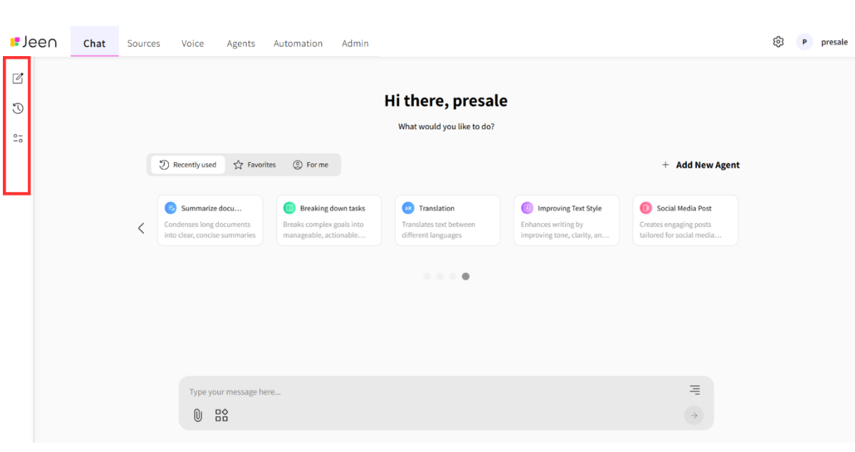

## 

## 

## 

## 

## 

## 

## 

## **Using Different Models in Chat**

By clicking on the side bar in the Control Panel, you can select the desired artificial intelligence model (LLM) for processing the conversation.

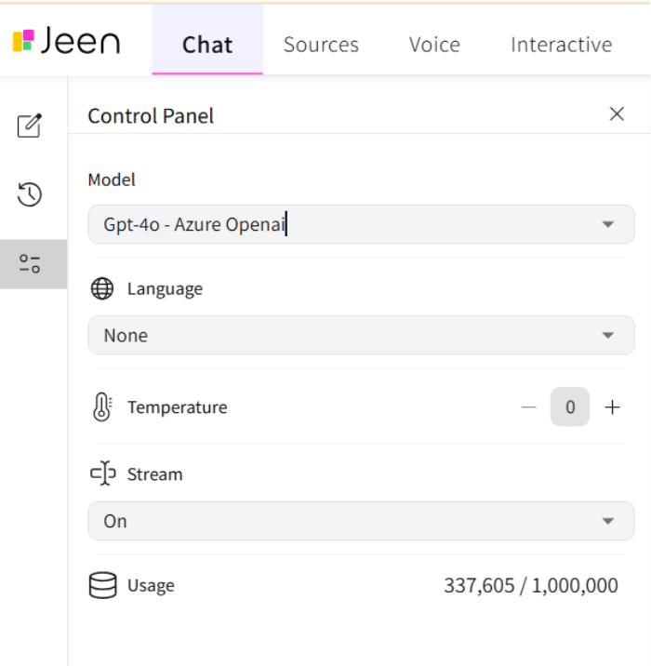

To get information about the model, you can hover your mouse over the desired model and an explanation about the model will open accordingly.

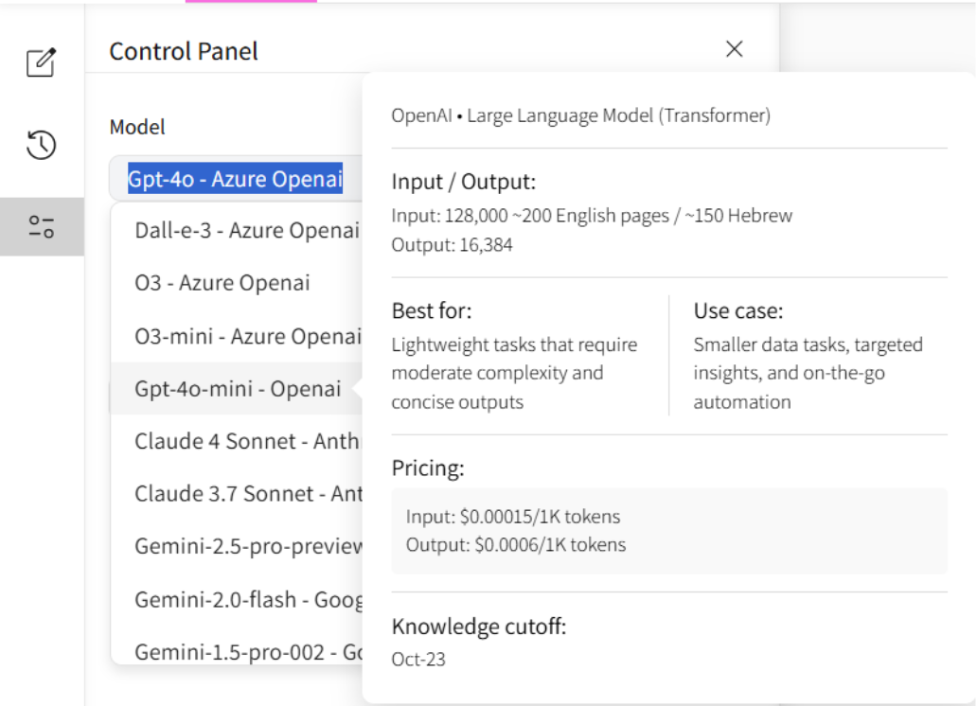

## **Temperature**

A parameter that controls the creativity level of responses:

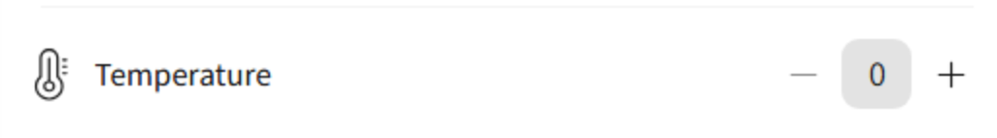

* Low value (e.g., 0.1) will produce accurate and predictable responses.
* High value (e.g., 0.9) will produce more diverse and creative responses.

## **Typing Animation**

Affects how responses are received. When we enable Stream, we receive the response in real-time with a typewriter effect. If we choose to disable Stream, the response will arrive after a few seconds all at once.

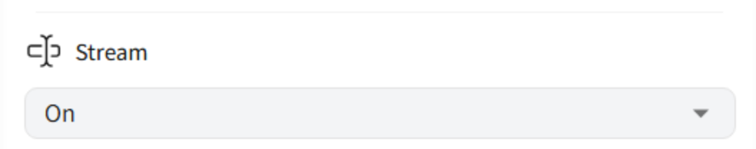

## **Automatic Translation**

Enable automatic translation for text sent to the model and/or the response received from it. You can choose the target language (Hebrew or English).

**Note:** Enabling translation requires disabling the Stream option.

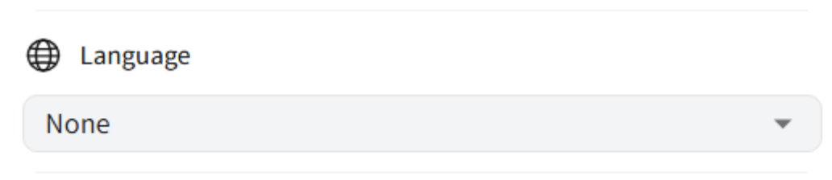

## 

## 

## **Token Allocation**

Displays the amount of tokens (information units) that have been used, out of the total allocation set for the user.

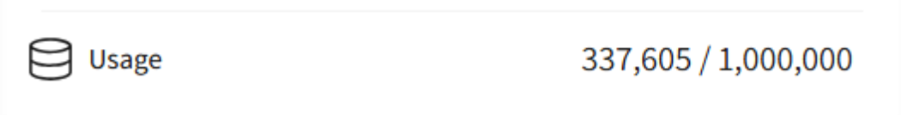

## **History**

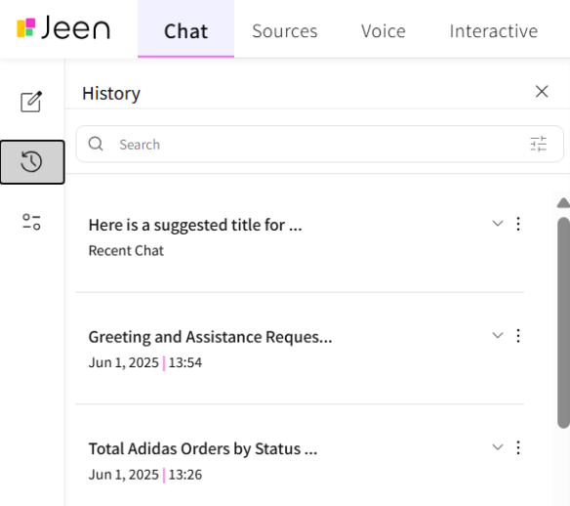

* Clicking the "History" button in the main navigation bar opens the chat history screen.
* By clicking the arrow button, we can see details of the conversation.
* Each conversation includes a title, date, and time. The chat name is automatically determined by the first message, and the most recent chat appears with a "Recent Chat" label.
* Chats are sorted from newest to oldest, with chats marked as Pin displayed at the top of the list.

## 

## 

## 

## 

## **Chat Search**

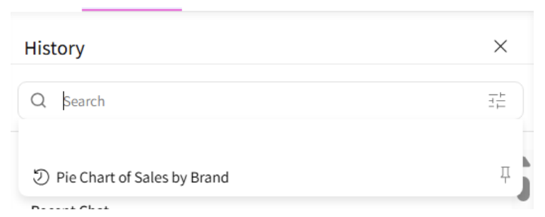

* The search bar appears at the top of the history screen.
* You can enter keywords and perform a free search among all previous conversations.
* Even in search results, pinned conversations will always be displayed first.

## 

## 

## 

## 

## 

## 

## 

## 

## 

## 

## 

## 

## **Chat Categories**

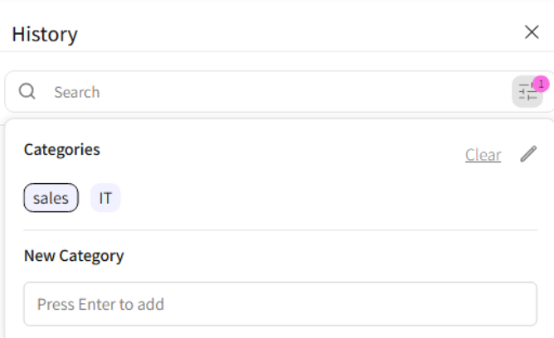

* Clicking the right button in the search bar will open the categories menu.
* To add a new category, enter the category name under the "New Category" field and press enter.
* When selecting a category, the category will be marked and the displayed chats will be filtered by the tag.
* To delete categories, click the pencil button and then the small trash can at the end of the category.
* To categorize a chat that took place, click the 3 dots → Category → mark the desired categories.

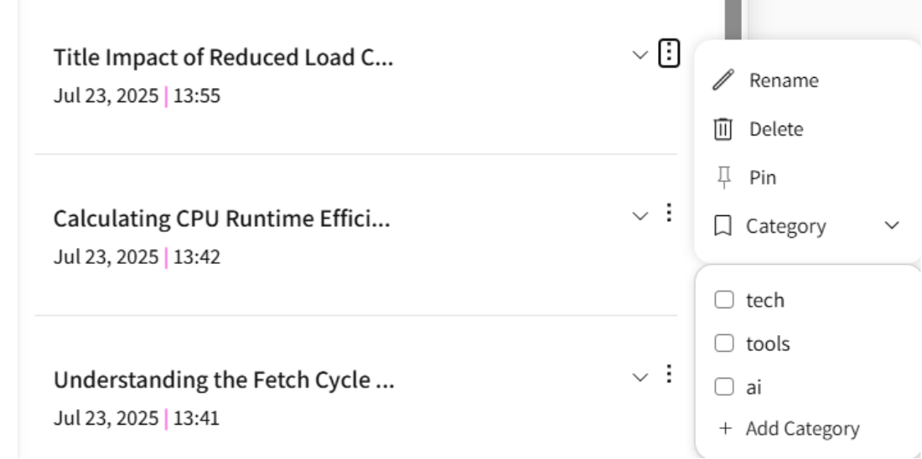

## 

## 

## **Resuming Existing Chat**

* Clicking on an existing chat will continue it from the last point.
* You can also click on a specific question within the chat and resume the chat from that point.

If the selected message has changed – a new branch will open with a different timestamp. Clicking on the new branch will continue the chat according to the change made, and clicking on the unchanged branch will continue the original chat as usual.

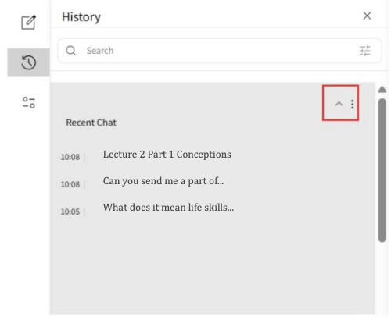

## 

## 

## 

## 

## 

## **Pinning Chat to Top of List**

* To pin a chat to the top of the history, click the 3 dots → PIN. Each chat includes a Pin button.
* Pinned chats will always be displayed at the top of the list, with appropriate marking.
* You can remove the pin at any stage.

